What is the structural similarities between a legal document, contract, agreement, etc (just like the employment contract, mobile subscription contract you signed), and a computer coding or program?

* Have similarities because:
  + - 1. Unlike everyday communication or literature writings rational and precise
      2. Should be human readable
* Structural similarities

1. top-down writing style

http://bactra.org/weblog/950.html

a document should have a clear structure

eg1.divorce doc: loan settlement / separation / marital settlement

eg2.

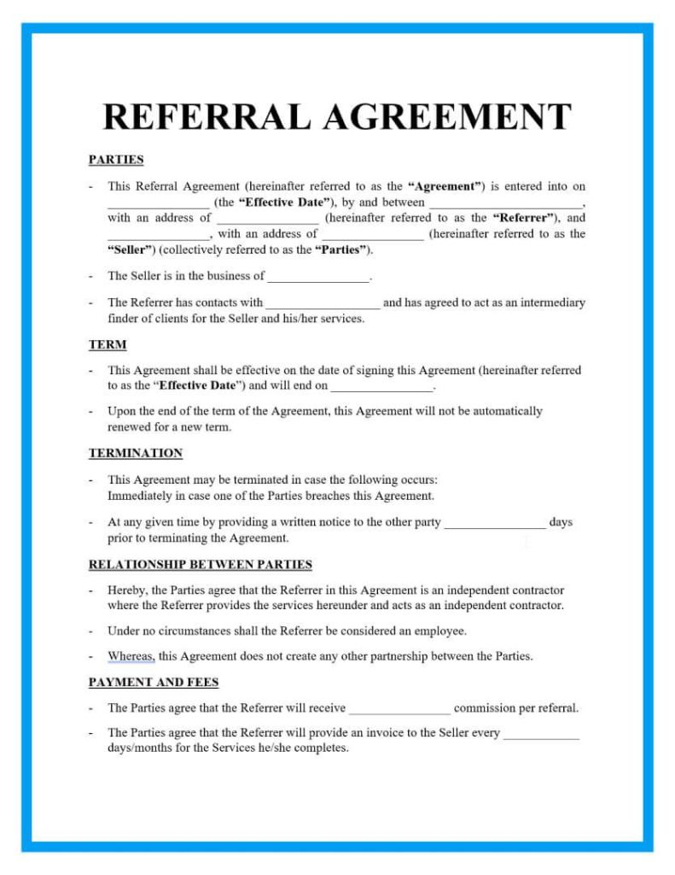

<https://signaturely.com/legal-documents-examples/>

1. the structure of sentences and the use of words

a. strict syntax

Specialized words and phrases unique to law

Ordinary words having different meanings in law

  long sentences with clauses vs. use braces and parenthesis to avoid ambiguity

1. citations and includes

back up assertions and statements with [citations](https://en.wikipedia.org/wiki/Legal_citation) of authority

* Conclusion
* citation

Wikipedia contributors, "Legal writing,"  *Wikipedia, The Free Encyclopedia,* <https://en.wikipedia.org/w/index.php?title=Legal_writing&oldid=1108102684> (accessed October 8, 2022).

**Structural similarities between legal documents and computer codes**

At the first sight, a legal document and a computer code might be totally irrelative. But having a deeper thought, we can find out that although they are used in different aspects of life, the writing of which has somehow the same propose: precisely express ideas or instructions based on the natural language we use every day. Therefore there should be some similarities in their writing structure.

Firstly from a general prospective, they all use a top-down writing style to organize the structure. That’s because legal documents and computer programs are both more focused in practicality, so they should be able to produce quickly (having a template to modify) and comprehended easily and precisely (Herbert, 1998).

For a legal document, writers first figure out what parts should be included and finish the outline first. Taking referral documents for example, we can usually see underlined big bold words dividing the articles into different sections of “PARTIES”, “TERM”, “TERMINATION” and “RELATIONSHIP BETWEEN PARTIES”.

For a computer program, engineers usually break a problem into several small problems and use function calls to make thing less complex.

Secondly, they both have rigorous structure of sentences and precise use of words, featuring a strict syntax and a many reserved terminologies.

As for the syntax, long sentences with clauses are often implemented in legal documents in order to avoid ambiguity, and in programing people often realize this by using many braces ({}) to show statements are in a same group and use semicolons (;) to end statements.

As for the use of words, both of the two writings have a lot of specialized words and phrases and have a unique meaning in its different field and they often have different meanings from how they are used every day (Barger, 2014).

Lastly, citations play an extremely important role in both writings.

In legal documents, great amounts of citations are used to refer to the authority and precedents to make the content more persuasive (Wikipedia, 2022). Computer engineers use preprocessors and preinstall packages to make use of those already existing function tools or data.

Looking for a reason of this, I think it is because both legal documents and computer programs are of practical use. Unlike literature works, they heavily rely on precedent performances and no one can have a complicated task done on its own.

In general, although legal documents and computer programs are of exactly different use, they have similar purpose and similar rules of organizing and expressing, leading to similarities in their structures.

Barger, C. M. (2014). ALWD guide to legal citation. New York: Wolters Kluwer Law & Business.

Herbert, S. (1996). The Sciences of the Artificial. Cambridge, Mass. : MIT Press.

Wikipedia contributors. (2022, September 2). Legal writing. In Wikipedia, The Free Encyclopedia. Retrieved 23:23, October 8, 2022, from <https://en.wikipedia.org/w/index.php?title=Legal_writing&oldid=1108102684>